# Project description:

## Background

### State of the art:

One of the hottest topics in condensed matter physics is the realization of a quantum computer. The main advantage of such a quantum computer would be its ability to solve specific classes of algorithms orders of magnitudes faster than classical computers.

As we all know a classical computer is based on deterministic two states called bits. A quantum computer is also based on two level states (basis states) called quantum bits (qubits). However, a qubit unlike q classical bit exploits the quantum effect of superposition. As a consequence, a quantum system can be simultaneously in both basis states.

There have been several proposals for implementing such a qubit (just solid state implementations are listed below):

* Electrons on Helium (He) [1]
* Semiconductors:
  + - Nuclear spin qubits [2]
    - Electron (hole) spin qubits [3]
* Superconductors:
  + - Flux qubits [4]
    - Charge qubits [5]

As stated above, one of the suggestions, which came in 1998 by Loss and DiVincenzo, was to use the spin of electrons (holes) for the realization of qubits. The spin is an intrinsic quantum mechanical property of every elementary particle. In a magnetic field the spin degree of freedom lifts the degeneracy of an orbital energy level. The level splits into two, typically labelled as spin-up and spin-down. This two level system can act as a qubit, the so-called spin qubit.

However, for accessing and manipulating the spin degree of freedom, one must first confine the charge into a region, which is in size comparable to the charge particle wavelength. Such a confinement can take place in a so-called quantum dot (QD). QDs are very small structures (their diameters can reach tens of nanometers) and because of their almost zero dimensionality, the energy levels for a charge particle are discrete and far away from each other. By applying external magnetic field spin energy states splits in two and become distinguishable for manipulation and readout. A few years after the Loss-DiVincenzo proposal for the realization of a scalable quantum computer, DiVincenzo published a list of conditions which a qubit should fullfill for a quantum computer to work correctly [6]:

The 5 criteria for quantum computation are:

* **Identification of well-defined qubits:** A well defined qubit is a two level (two state) system whose levels are distinguishable and highly controllable. The qubit operation takes place by operating (manipulating) this two states.**Reliable state preparation:** To be able to always deterministically drive the qubit into the initial state so it is ready for the next computation.
* **Low decoherence times (long coherence times):** Because of the several noise sources coupled to the qubit its initially prepared state is lost (decohered) with the time. It is desirable to have coherence time as long as possible.
* **Accurate quantum gate operations (state manipulation):** As it is known, in a classical logic operators (gates), the input states (voltage levels) act on the transistors switching them on or off and thus determine an output state (voltage level). Quantum logic gate state is represented by the qubits spin directions. Gate operation in the quantum logic consist of rotations of this spins around different (operation defined) axes, for the operation defined angles. Rotations are usually achieved by means pulses which duration define rotation angles and it needs to be very accurate.
* **Strong quantum measurements (state readout):** Quantum measurement is a projection of a qubit spin vector from a calculation determined position (qubit state) to the basis state axes and obtaining the result as up or down (state readout).

**In all spin qubit approaches above (and all qubits in overall) there is battle between the spin manipulation time on one side and the coherence time on the other side. For making a set of quantum operation correctly, the manipulation time for one operation need to be much shorter than the coherence time. Benchmark for the manipulation time is minimum time needed for one full spin rotation (π pulse), τπ.**

**Materials**

Silicon **(Si)** has emerged as a promising material for the spin qubits because it can be isotopically purified and left just with the 28Si isotope which is a nuclear spin zero element. Thus the nuclear noise can be eliminated and the coherence time boosted in comparison to the broadly used gallium arsenide (GaAs) in a spin qubit community today. The additional big advantage is its compatibility with current CMOS technology. This could become very important when moving towards the realization of a large number of qubits as required by quantum algorithms.

(speak about the three types of Si quantum dots dzurak, Eriksson,, heterostructures, Morello and what Simmons does with STM. In this discussion it needs also to come out that geometries are getting more and more complex there are people fabrication quintuple dots) There are several approaches of defining quantum dots in silicon, in which qubits are achieved at the moment.

One way is by means of a phosphorous P doping in the specific Si crystal regions. In that case a phosphorous atom behaves as an electron quantum dot because of its confining potential. Andrea Morello’s Group from the UNSW in Australia, by applying the Hahn echo pulse sequence, has measured the electron spin coherence time T2 exceeding 200 microseconds, in a non – isotopically purified Si:P system, while the duration of π pulse in this case τπ = 75 ns [3]. By using the isotopically purified 28Si:P and the nuclear spin of phosphorous atom as a qubit, the same group has achieved nuclear spin coherence time of 60 milliseconds and duration of the π pulse of around τπ = 50 μs [2].

M. Veldhorst et al. by using lithographical definition of electron quantum dots in silicon has measured spin coherence time using CPMG pulsing technique T2CPMG = 28 ms and the π pulse duration time for that case is τπ = 1.5 μs [17].

E. Kawakami et al. by using the single-electron quantum dot in the Si/SiGe heterostructure with two layers of the electrostatic gates as a qubit, has measured the coherence time using the Hahn-echo pulse sequence T2 = 40 μs. Spin flip duration is around τπ = 0.15 μs, extracted from supplementary information [18].

The major drawback in silicon is the relatively weak spin orbit coupling for electrons which results in difficult spin manipulation via electric fields (as described in more detail in *The spin manipulation measurements*). One solution around this problem is to use holes instead of electrons.

Using hole spin in p-type silicon industrial CMOS as qubit basis, R. Maurand from S. De Franceschi group in CEA Grenoble, achieved π spin rotation time of approximately τπ = 3 ns. While coherence time using Hahn echo pulsing sequence T2 in their case was 245 ns [11].

Holes in germanium **Ge**, on the other hand, have much higher spin orbit coupling which should lead to much **faster spin manipulation time**.

Another other way for defining QDs on a silicon based platform, used in our group, is by combining it with germanium Ge [10].The epitaxial growth of Ge on Si can lead to the formation of QDs and and hut wires (a special type of nanowires) due to the different lattice constant between them. Recently magnetotransport measurement have shown that holes, in this type of structures, are of the **heavy hole type** what leads to the **longer** dephasing and thus longer **coherence times**.

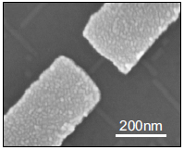

Figure 1: Scanning electron micrograph of SiGe nanowire contacted by palladium Pd source and drain electrodes [10]

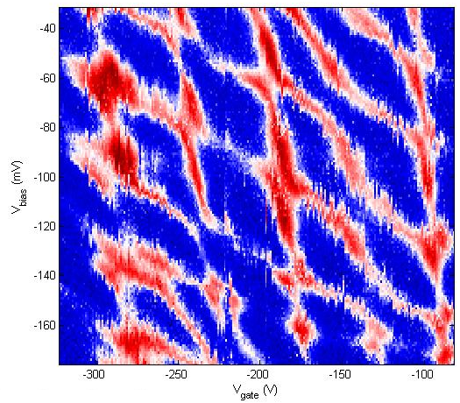

Figure 2: Stability diagram of a SiGe nanowire double quantum dot

Scale up demand of a quantum computation requires qubit coupling. Spin qubit community is trying to reply on that with several approaches: From C. M. Marcus and Quantum Transport laboratory in Delft – triple quantum dots. From D. J. Reilly laboratory - quadruple-quantum-dot. From S. Tarucha laboratory - quintuple quantum dot.

Different type of measurement techniques are applied in order to measure the state of a spin qubit and extract the coherence times:

* DC current readout
* Differential measurement (AC current readout)
* Ohmic reflectometry
* Gate reflectometry

The DC current readout is sensing the electron transport through the qubit by means of current measurement. It is prone to low frequency 1/f noise and BW is low because of heavy filtering for achieving low effective electron temperatures.

Differential measurement (AC current readout) has the same drawbacks as DC current readout. It is typically done with low frequency lock in technique. Because of the low frequency noise, lock in amplifier usually operates on very narrow bandwidth around frequency of the measurement sinusoidal signal, which lead to long measurement time.

Ohmic reflectometry is a technique of indirect qubit impedance change sensing by monitoring the amplitude or phase of the wave reflected from the qubit (see Figure 3 for a more detailed explanation). It is usually done by high frequency lock in techniques and is not prone to 1/f noise.

Finally, gate reflectometry is a technique of indirect sensing of the change in the qubit capacitance by monitoring the amplitude or phase of the portion of the sent wave reflected from the one of the qubit gates. **It’s big advantage is that it does neither require charge transport through the qubit nor the existence of a no charge sensor.**

**What is reflectometry?**

**C:\Users\jkukucka\Documents\GitHub\Fellowship\Reflectometry_basics.tif**

Figure 3: Basic principle of ohmic reflectometry. CS and RS constitutes the equivalent electrical schematic of a measured sample, e.g. a single hole transistor (SHT) formed by the single quantum dot. S and D denotes source and drain contacts of the single SHT, respectively. The resonance circuit formed with an inductor L and a capacitance C is connected to the source contact.

Reflectometry is a readout technique based on the change of the wave reflection coefficient Γ. It comes from the electromagnetic wave principle – if a wave is travelling in a media with impedance Z0  (e.g. coax cable) and it encounters a change of impedance (e.g. coax end) to Z, a portion of the wave will be reflected back according to the expression: , where Ar is amplitude of a reflected, Ain amplitude of an incoming wave and Γ is reflection coefficient.

By putting a resonant circuit connected to a single hole transistor (Figure 3, red polygon) instead of coax cable end one can measure its impedance change due to a hole tunneling. If elements of a resonant circuit, inductance L and capacitance C are properly chosen, on the resonant frequency of that circuit, , wave reflection coefficient Γ is minimized. Proper choosing means achieving the matching condition. Matching condition is situation in which large resistance (~100 KΩ) of the single hole transistor is transformed to near 50 Ω value what is characteristic impedance of the RF line Z0, thus minimizing reflected signal. In that case change in a reflected signal amplitude due to SHT charge configuration change is maximized and consequently measurement sensitivity is maximized [13].

Thus, if a hole tunnels -> SHT impedance changes -> Γ changes -> amplitude and phase of the reflected wave changes.

### Definition of the problem:

**Since the charge transport through the qubit, in majority of our experiments is not allowed, all readout techniques based on charge transport are not applicable since no current is flowing. Readout techniques in this category are DC current readout, AC current readout and ohmic reflectometry.**

A usual solution to this problem is to place next to a measured qubit an additional, separated quantum dot in the form of a single electron (hole) transistor or quantum point contact, called charge sensor. The charge sensor is electrostatically coupled and thus sensitive to the charge configuration in the qubit. The charge sensor itself is well coupled to ohmic contacts thus it is suitable for charge transport measurements and ohmic reflectometry.

**However, charge sensors suffer from conductance profile thermal broadening what lowers the sensitivity thus speed of readout. They also need an additional compensation gates to substract the influence of the qubit gates on their conductance. Also, by looking into the future, for the realizatioin of a usable quantum processor, the qubit number needs to be drastically scaled up to achieve a large enough number as required by quantum algorithms.** **Gate reflectometry does not suffer from previously listed problems and since it is using already defined electrostatic gates it does not need a charge sensor, thus has a big potential to address the scalability problem.**

Using in-situ gate electrodes already defined for tuning double quantum dot in GaAs/AlGaAs heterostrucure connected to the lumped element resonator as a gate reflectometry circuit, J. I. Colless et al. from D. J. Reilly group, achieved charge sensitivity of 6.3 meHz-1/2 (smaller is better) [14].

Last year, M.F. Gonzalez – Zalba et al. reported a charge sensitivity of 37 μeHz-1/2 by using the similar gate reflectometry approach for silicon nanowire based double quantum dot (DQD) device [12]. The reported sensitivity is similar to that achieved with ohmic reflectometry in charge sensors (RF quantum point contact and RF single electron transistor) which is in μeHz-1/2 regime [12], but suffers from all the issues stated above.

### Proposal objectives:

The objectives of this proposal are to **design a** **fast gate reflectometry** system which will be used in order to study the Loss-DiVincenzo qubit created in a germanium based, double quantum dot.

For the gate reflectometry, the goal is to achieve a charge sensitivity comparable or even faster than the one reported in [12]. That would allow us to have a high bandwidth system necessary for the qubit read out. After the gate reflectometry would have been set up the focus will go to the realization of the Loss-DiVincenzo hole qubit in a DQD structure. The first measurements to be performed are the ones for determining the spin relaxation time T1 during which the spin stays in the excited state before relaxing to the ground state. Subsequently experiments in order to investigate the coherence time of the qubit are going to be performed. More concretely, spin manipulation experiments for measuring the spin dephasing time T2\*, the spin coherence time using Hahn echo technique T2, and the spin coherence time using the CPMG pulse sequence technique T2CPMG, are going to be conducted.

### Working schedule:

#### Designing initial version of reflectometry setup: sample holder, readout circuit, instrumentation setup

**Sample holder**

In order to tune the gate reflectometry system, measurements will be initially performed at the temperature of 4K, in the liquid helium, on the single hole transistor, quantum dot sample. Such temperatures are needed to lower the electrons thermal energy to be able to resolve energy level splitting in a quantum dot. During the first year of my PhD I have already prepared a 4K dip stick for such a reflectometry measurements.

For this purpose Plexiglas stick (Figure 5), were used. The quantum dot sample can be positioned on the top of the stick on the so called sample holder. Since, electrical signals needs to be delivered and afterwards measured from the sample, the sample holder is done as printed circuit board (PCB) which routes all the electrical signals to and from the sample. From the room temperature instruments, DC electrical signals are sent through the low thermal conductive twisted pair wires finishing in a PCB connector and radio frequency signals are sent through the coaxial cables. Going from the PCB DC connector, DC signals are low pass filtered with surface mounted RC filters (Figure 4) to reduce thermal noise from the wires. After low pass filtering, DC signals are routed to the gold plated bonding pads around area in the middle of the PCB (sample area) on which a typically 5x5 mm sample is glued with a silver paste (Figure 4). Electrical contacts from PCB bonding pads to on the sample bonding pads electrically connected to the quantum dot gates are achieved by wedge wire bonding technique. RF coaxial lines are finishing on the PCB mounted SMP connectors. After SMP connector, using the bias tee, DC signal is added to the RF signal. From there signal is routed to the PCB bonding pads. SMP connectors and bias tees can be seen on Figure 4. Further these signals are connected to the quantum dot gates with the same wedge wire bonding technique.

**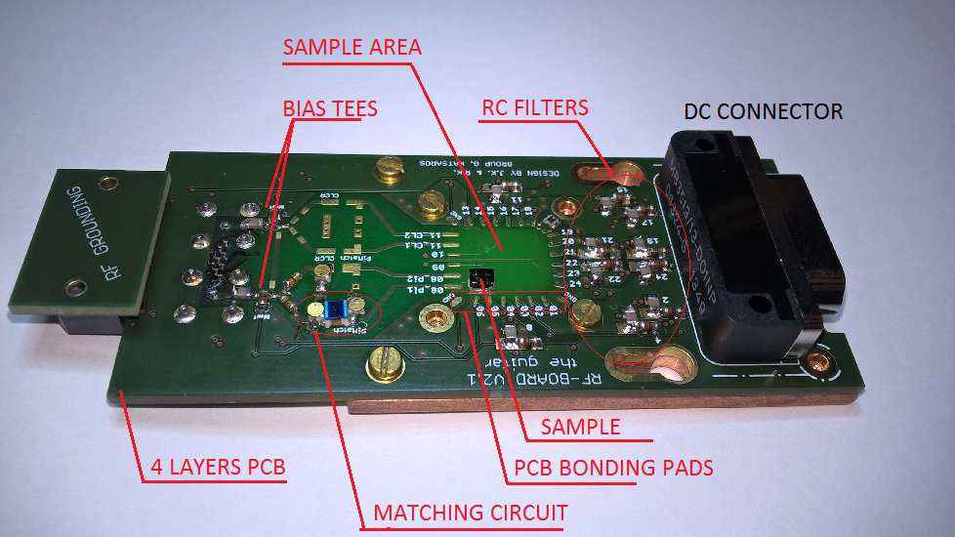**

**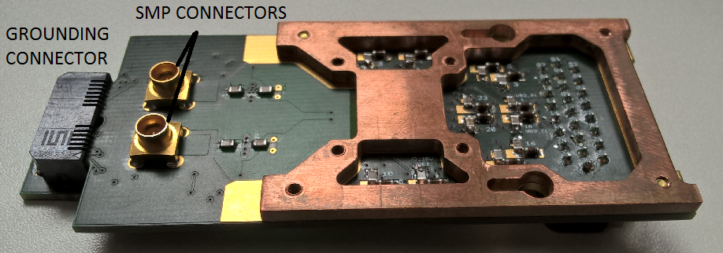**

Figure 4: Initial version of the PCB sample holder. The top figure show the upper view of the PCB board while the lower figure focuses on the back side.

**Readout circuit**

To measure the charge state of the nanowire single hole transistor, ohmic reflectometry technique was applied. For that purpose the RF signal was sent down the coax line (Figure 5, right). The signal reflected from the resonant circuit was separated in the directional coupler and directed to the amplifiers. Amplifier configuration, shown in Figure 5 (right), is used to preserve the signal to noise ratio (SNR). Going from the sample, very low noise cryogenic amplifier, Weinreb’s CITLF2, is used to amplify both signal and noise for the same amount (around 20 dB), adding very small amount of itself noise, thus almost preserving the SNR. Achieved SNR has much higher noise boundary allowing the second, noisier amplifier to lift that boundary even higher for the next room temperature instrumentation stages, without influencing it.

The used resonance circuit consisted of a matching circuit (Figure 4) and the SHT resistance RS in parallel to the capacitance CS, as can be seen in a simple circuit model in Figure 3. Finally there always exists a parasitic capacitance in parallel to CS, which is a capacitance to the ground that comes from bonding wires, the sample itself, the RF line and the used inductor.

Matching circuit elements used are the surface mounted inductor Murata 1.2 μH and varactor MACOM MA46H070-1056. Varactor – a voltage tunable capacitor - was used to be able to always achieve good matching condition despite the change of the SHT resistance Rs following the approach in [13], as explained in “What is reflectometry” section of the “State of the art” chapter.

*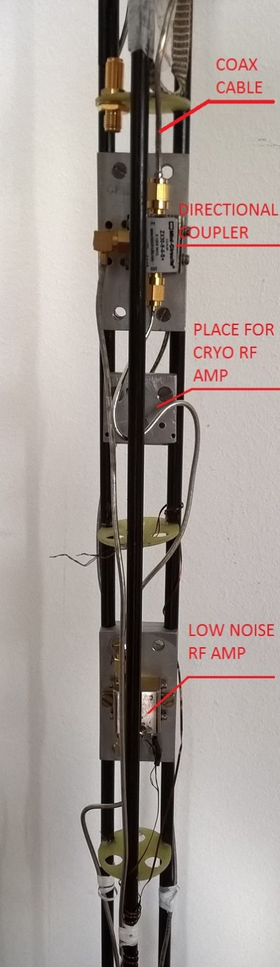*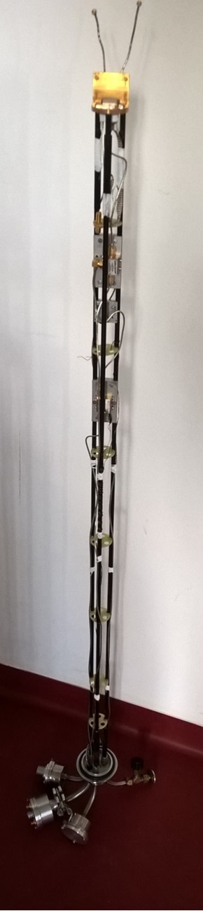

Figure 5: Plexiglas dip-stick used for cooling down samples to 4K. The left picture shows the whole stick, while right is the zoom in, highlighting the directional coupler and low noise Minicircuits ZX60-33LN-S+ RF amplifier. An additional low noise cryogenic RF amplifier CITLF2 from Sander Weinreb’s Caltech Microwave Research Group can be added in order to increase the SNR of the measured signal.

THINGS THAT ARE KICKED OUT, BUT MAYBE SOME OF THOSE CAN BE IMPLEMENTED ABOVE:

*Measurements need to be sensitive enough to achieve a high enough signal to noise ratio (SNR) (typically SNR of more than 10) in a short time. Signal to noise ratio is the ratio of signal and noise amplitude in a given bandwidth. Measurement sensitivity is a measure of the change in an amplitude of current or amplitude (phase) of reflected wave when charge configuration is changed. Noise comes from 1/f noise on lower frequencies, intrinsic shot noise, thermal noise, noise in in measurement equipment… Lowering the measurement bandwidth (integration or filtering) noise is lowered and SNR raised but measurement become slower. Thus for achieving good SNR in short time signal need to be high. In our case fast measurement is required to obtain good quality measurement fast enough. (I think this part does not fit here, should be put when you explain how you will tune your reflectometry what is important)*

**Double quantum dot (DQD) (Use this part when you will describe your experiment in a DQD)**

For achieving good state preparation, fast manipulation and fast measurement, additional mechanisms are required beyond ones offered by single QDs. One of the most promising building block for the realization of the spin qubit quantum computer based on quantum dots is serial double quantum dot (DQD) system. A DQD system consists of two neighboring quantum dots tunnel coupled to each other, which simply means that they can exchange charge particles by tunneling. The

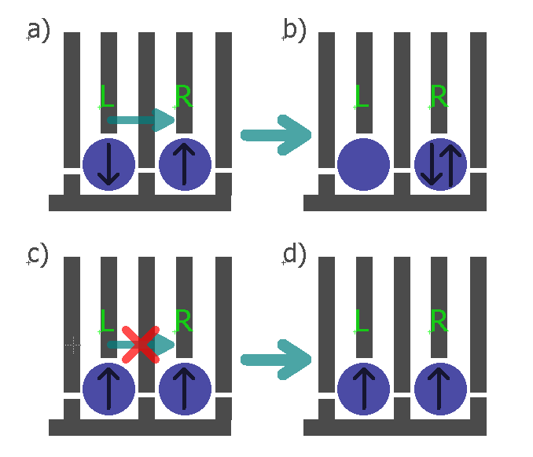

Figure 1: Spin state readout based on spin blockade in gate defined electron DQD. The blue circles represent the individual quantum dots, the grey lines the gates and the black arrows in the QDs the electron spin direction in the left and the right dot. In the case of two electrons on the right dot current through the charge sensor does not flow, otherwise it flows (NO!). I think you should not use here the charge sensor. Spin blockade can be observed also in a current measurement. I am afraid that the concepts are getting too much mixed.

main physical property which makes them favorable for the realization of a qubit is the Pauli exclusion principle. It says that two identical fermions (in this specific case electrons or holes) cannot occupy same energy state.

Figure 1 describes how spin blockade can be used to extract information about the electron spin in the left QD in the DQD system. If the spin configuration is like in Figure 1a) then after electrostatic pushing, by applying voltage pulses on gates L and R, electron is allowed to tunnel to the right dot, which, for example, can be detected as the DC current signal. In the other case, Figure 1c), electrons on both dots have same spin and due to Pauli exclusion principle they stay in that configuration after electrostatic pushing. Consequently, current DC current signal does not flow. (You need to speak about singlet triplet else it is not clear)